## **Lab 16 – Power BI Parameters**

**Dynamic reports with parameters**

Dynamic reports are reports in which the data can be changed by a developer, according to user specifications. Dynamic reports are valuable, as a single report can be used for multiple purposes. If you use dynamic reports, you'll have fewer individual reports to create, which will save Organizational time and resources.

You can use parameters by determining the values that you want to see data for in the report, and the report updates accordingly by filtering the data for you.

**Exercise 1 – Parameters in ExcelSheet as data source**

1. Open our Demo Report
2. Go to transform Data and open Power Query editor

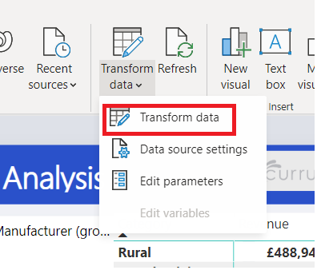

1. Go to View Tab and verify Always allow check box checked.

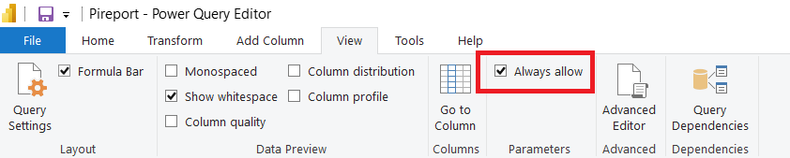

1. Go to Home tab and Click manage Parameter and select new Parameters

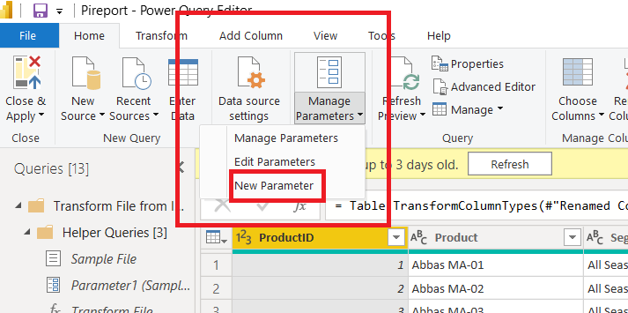

1. Create Two Parameters
   1. FromDate
      1. Set Current Value 01/01/2013
   2. ToDate
      1. Set Current Value 31/12/2020

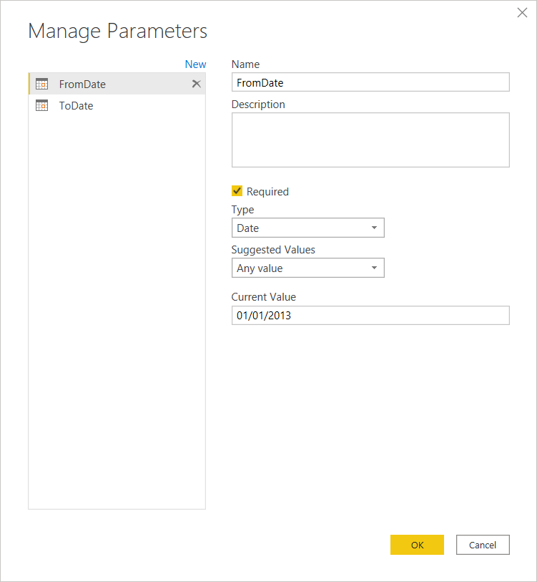

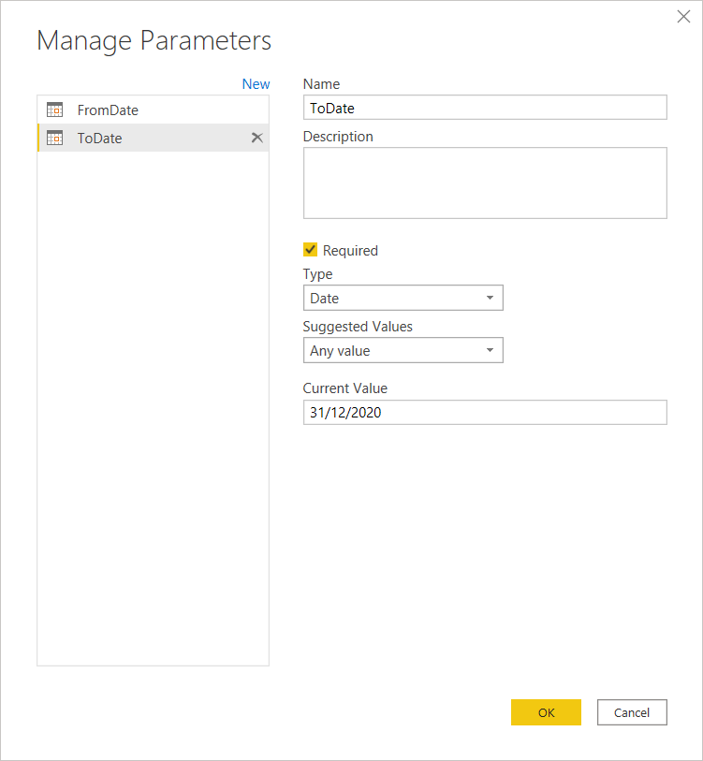

1. Click Ok to save it

Implement the parameter in Table

1. Go to sales table
2. Select Date Column

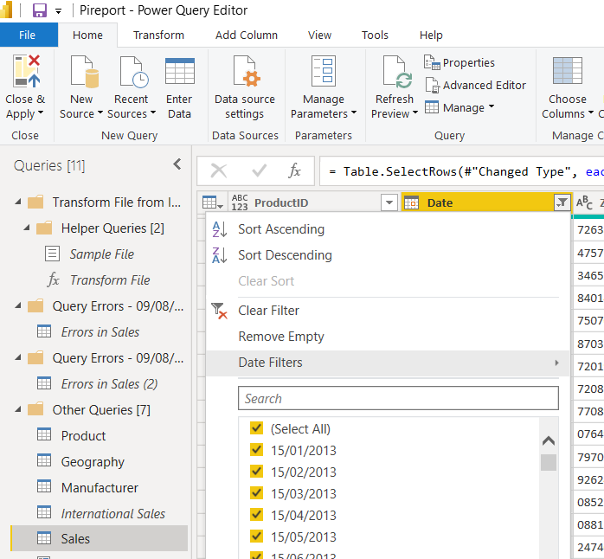

1. Select date filter and select custom filter

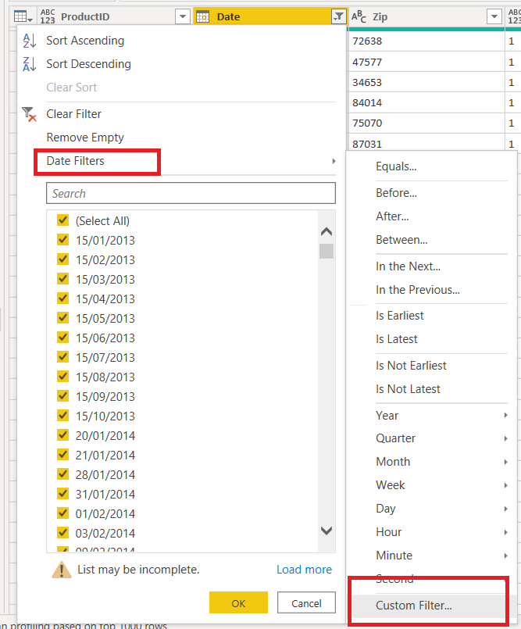

1. Is after – From Date parameter
2. Is before – To Date parameter

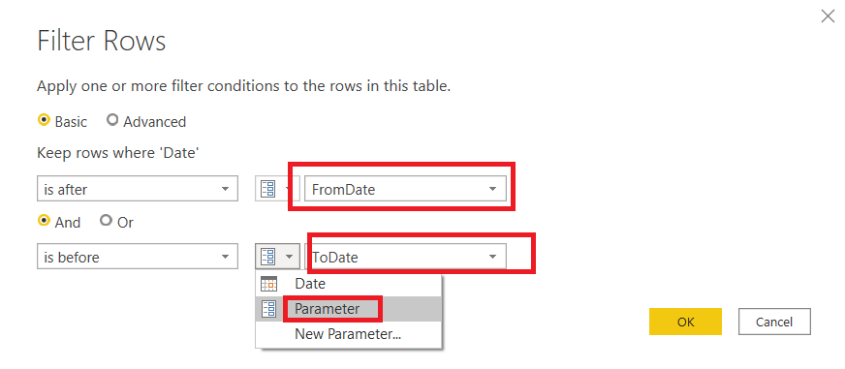

1. Click ok to apply it
2. Close and apply Power Query Editor
3. Now you can be able to update the filter without opening Power Query Editor

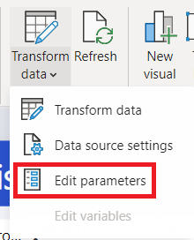

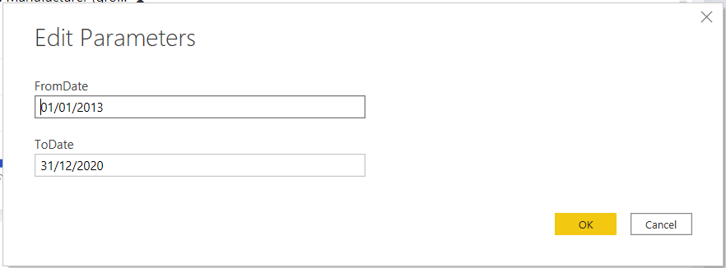

1. Update the dates and click ok and click apply changes button to apply the changes

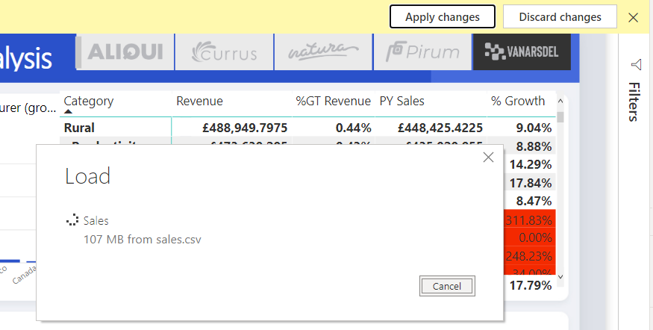

1. Publish the report

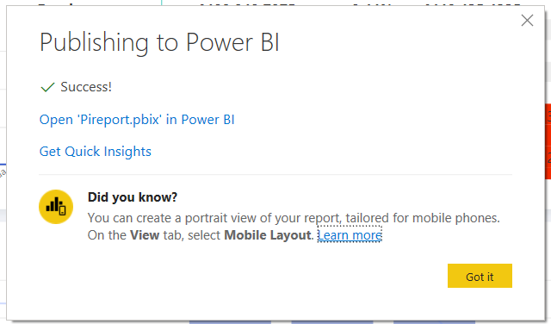

1. Open Power BI Service and go to Dataset
2. Click Settings

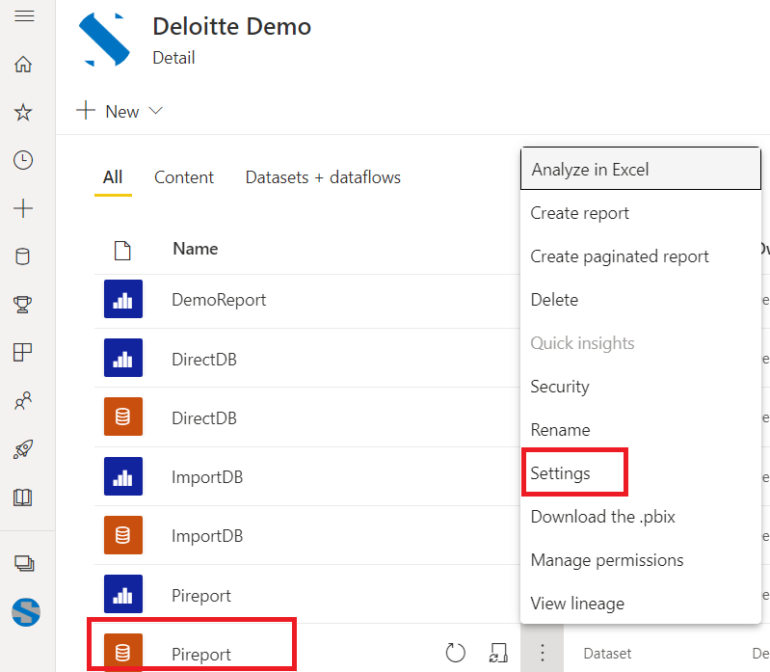

1. Go to Parameters and update it and click Appy to update the data

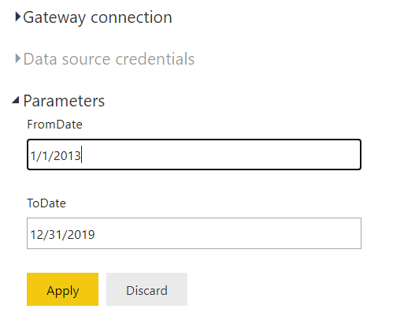

Update from date to 1/1/2016 and To date to 12/31/2018

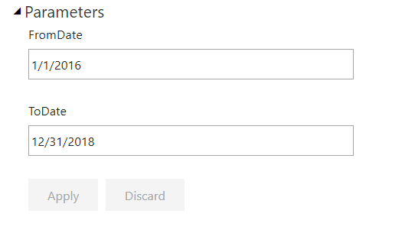

Update Gateway

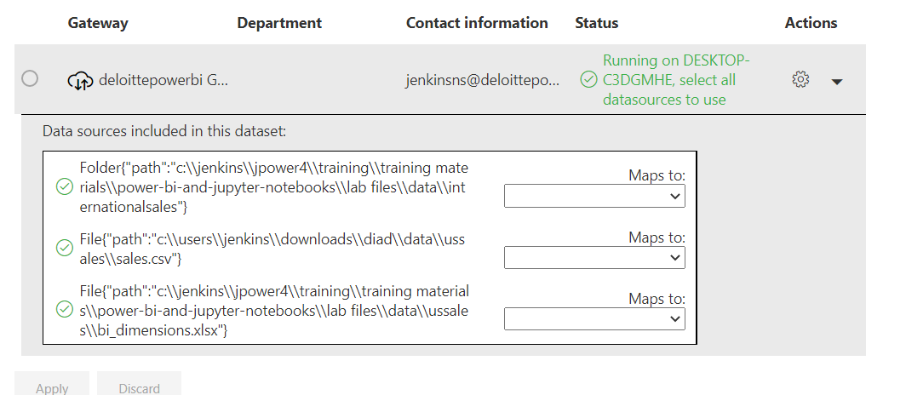

Refresh the Dataset (on demand Refresh)

Go to the report and refresh you get the new data report

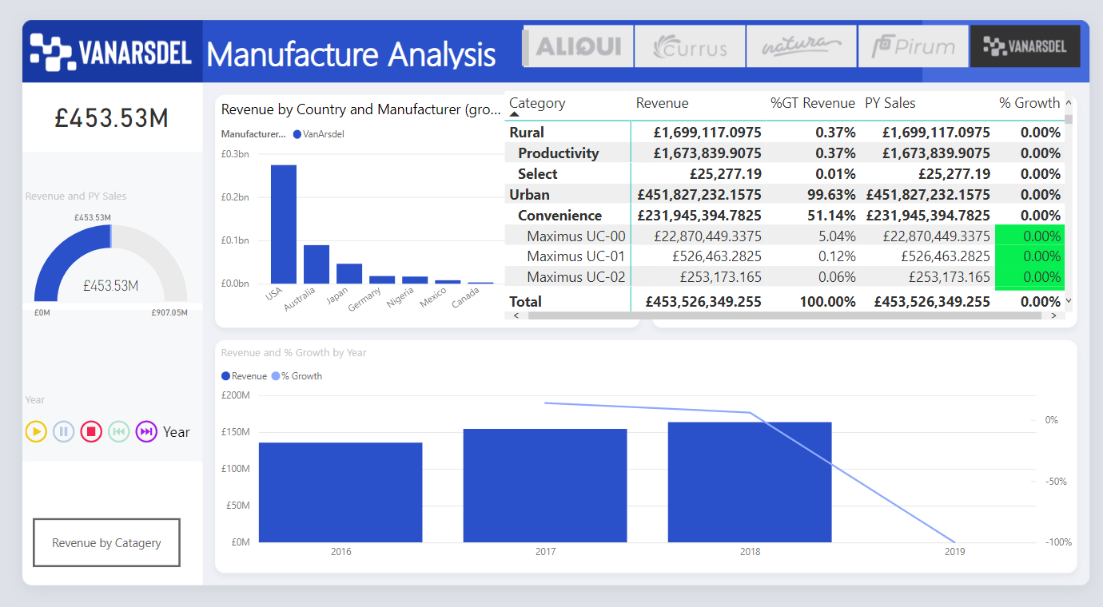

Exercise 2 – using SQL Statement

In this example, you connect to your database on SQL Server. In the SQL Server database window, after you enter your server details, select the Advanced options, then paste the SQL query into the SQL statement box, and then select OK.

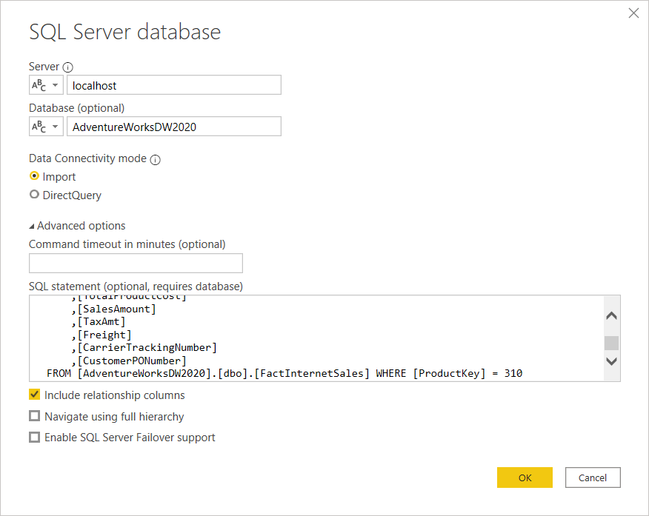

SELECT TOP (1000) [SalesOrderNumber]

,[SalesOrderLineNumber]

,[OrderDate]

,[DueDate]

,[ShipDate]

,[ProductKey]

,[CustomerKey]

,[PromotionKey]

,[CurrencyKey]

,[SalesTerritoryKey]

,[OrderQuantity]

,[UnitPrice]

,[ExtendedAmount]

,[UnitPriceDiscountPct]

,[DiscountAmount]

,[ProductStandardCost]

,[TotalProductCost]

,[SalesAmount]

,[TaxAmt]

,[Freight]

,[CarrierTrackingNumber]

,[CustomerPONumber]

FROM [AdventureWorksDW2020].[dbo].[FactInternetSales] WHERE [ProductKey] = 310

1. Click connect and click Transform Data
2. Create Parameter

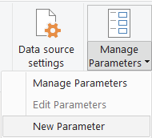

1. Parameter name – ParamProductKey

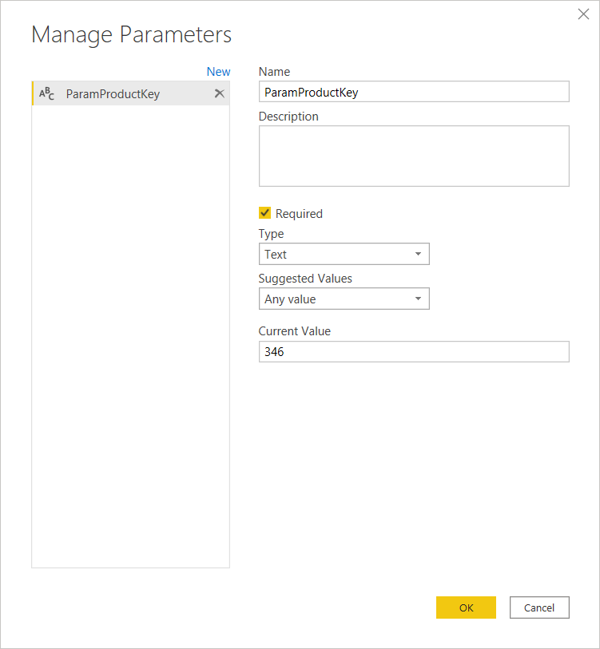

Update the Query with Parameter **&ParamProductKey**

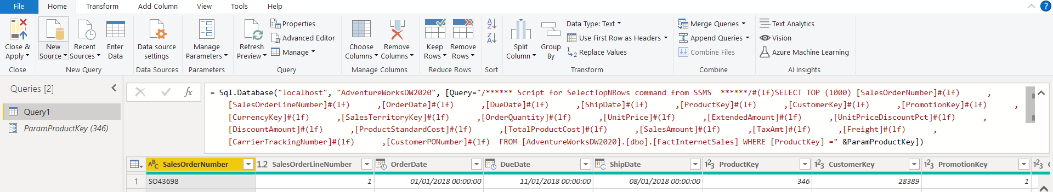

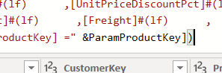

Close and Apply

Add visual

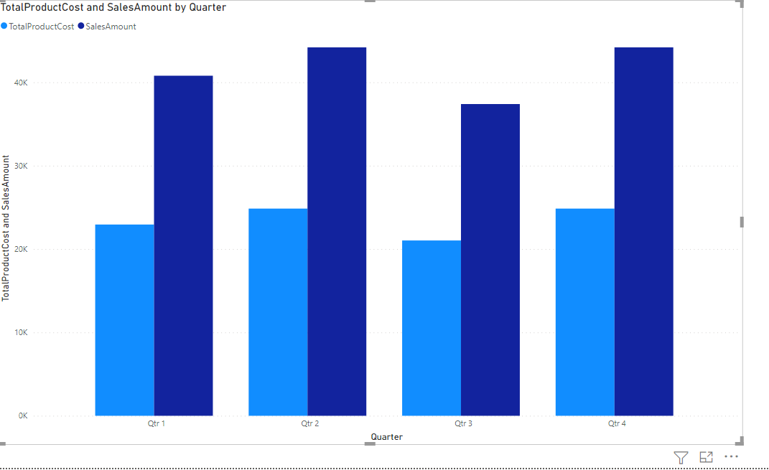

Then publish the report

Update the parameter based on the requirement via dataset parament

